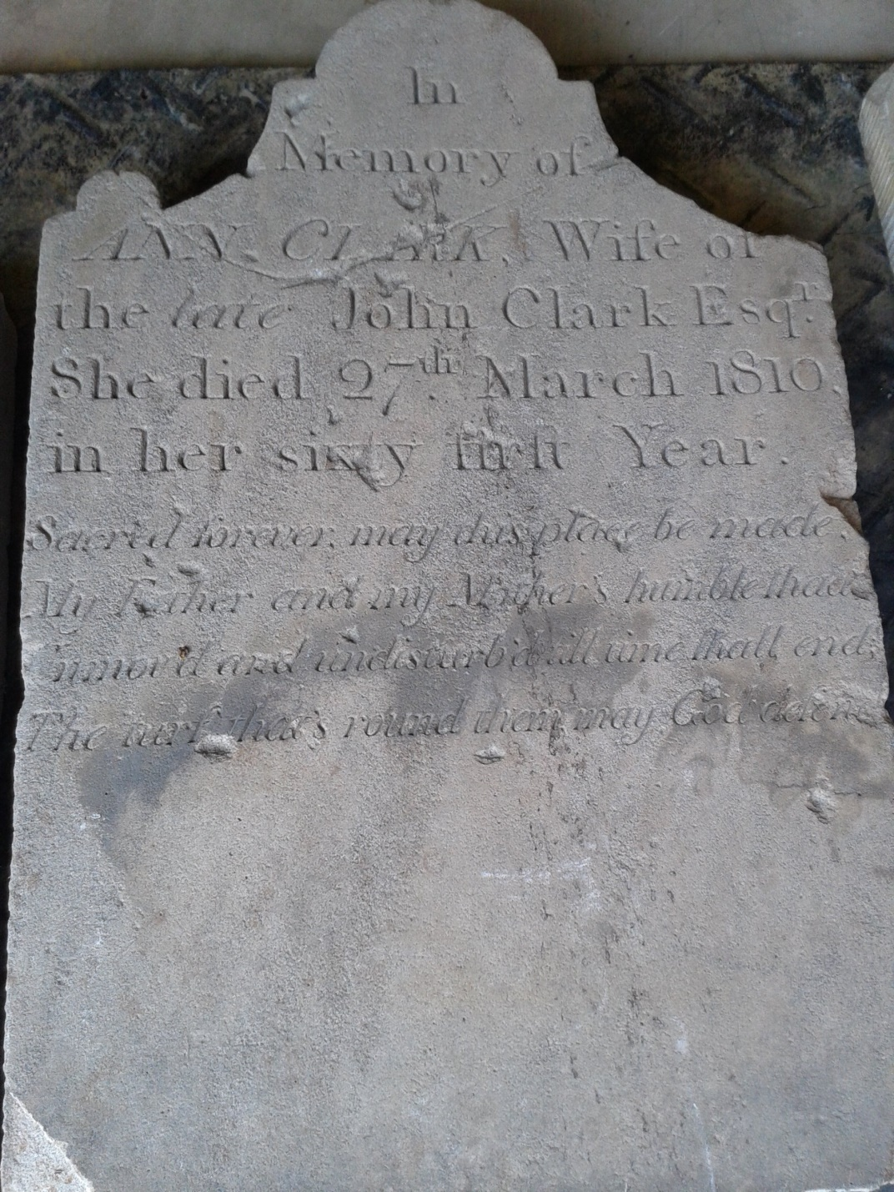

# The Clark Family Memorial Cemetery Dedication

**June 24, 2017 11am**

The following verse is the Inscription on Ann Clark’s gravestone likely written by her daughter Sarah Jupine Clark. Ann A. Clark was the wife of John G. Clark for whom our town of Clarksburg is named.

“Sacred forever may this place be made,

My Father and my Mother’s humble shaid

Unmov’d and undisburd’d til time shall end,

The turf that’s round them may God defend.”

Today we honor Sarah’s wish by recreating a sacred place where the Clark Family and those buried in their family cemetery may be remembered.

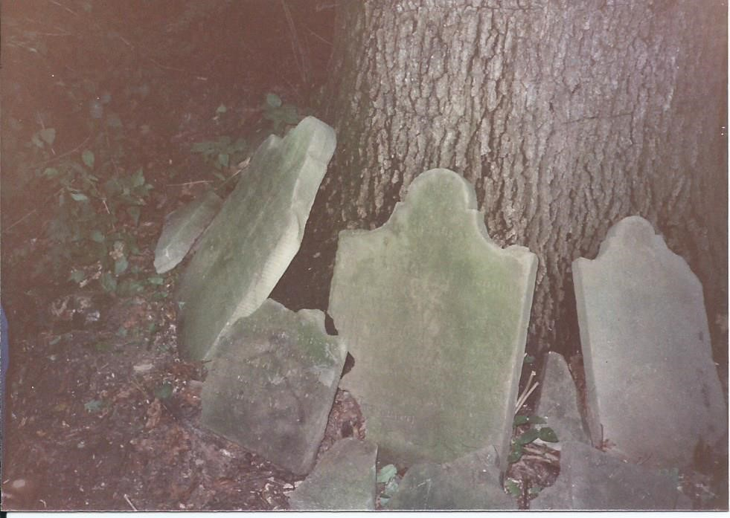

**PROGRAM**

Amazing Grace- *first published in 1779. Performed by Dale Hayman on harmonica.*

Welcome- Frances Foreman

Craig L. Rice- Proclamation

The Long Path Home- Jean Hulse-Hayman Story of the Clark Family Memorial Cemetery including a personal remembrance by Margaret Williams

We Gather Together - Performed by Caty House

Recognitions- Jean Hulse-Hayman

Unveiling of the plaque

Ribbon Cutting

Blessing- Reverend Hodsdon, Clarksburg United Methodist Church

**Please join us today at Clarksburg Heritage Day!**

Take a 5 minute car ride and park at 23425 Spire Street.

Free shuttle ride to 1909 schoolhouse, moon bounce, face painting, live music, history displays, and more! Noon to 4pm

***The power of one man or one woman doing the***

***right thing, for the right reason, and at the right time,***

***is the greatest influence in our society.***

***By Jack Kemp***

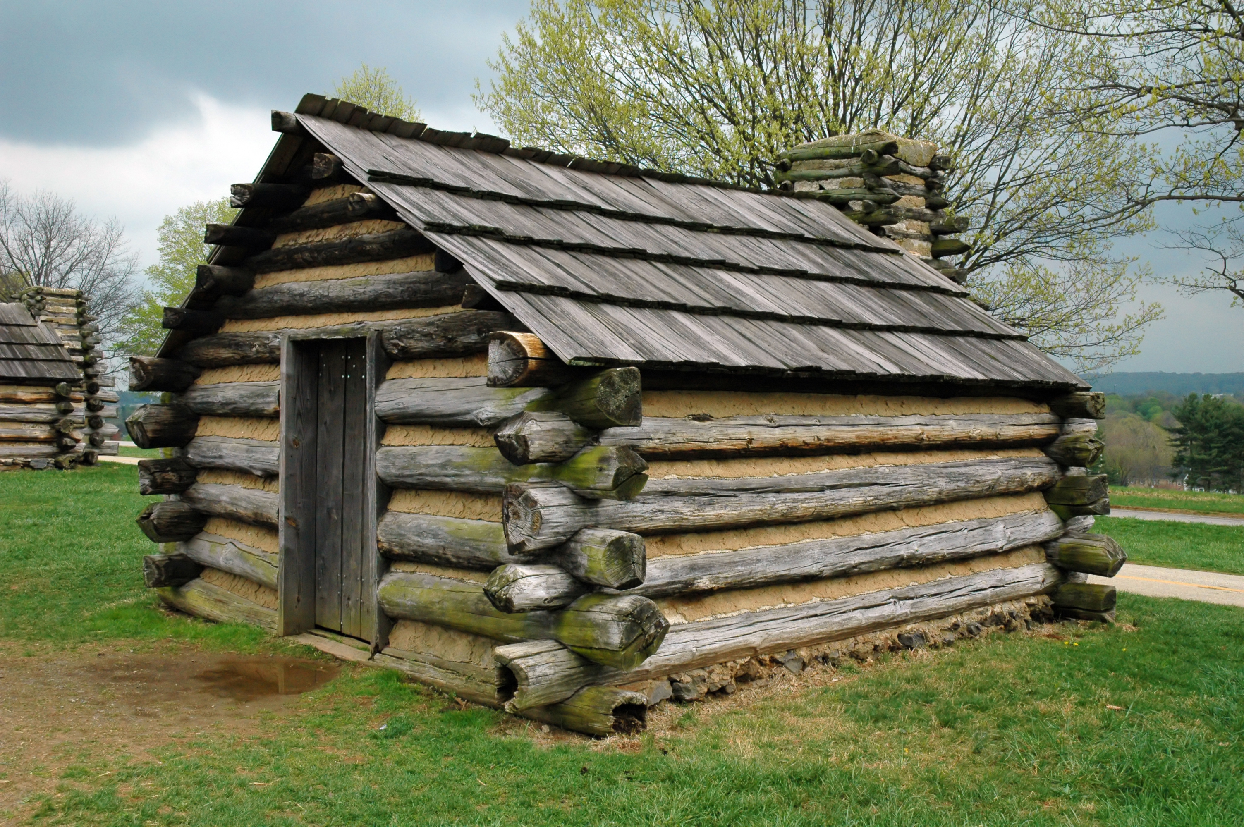

In 1781 John G. Clark, our town founder, built his home in Clarksburg. At the site his grandfather’s trading post, he established a general store. In 1790, he surveyed the town and laid out lots. He was a founding member of the Methodist Society which formed in 1788 and the Methodist Episcopal Church which began as a log chapel in 1794. In 1798 he was appointed the first town Justice of the Peace. In 1799 he served as county commissioner, and in 1800 he was the first town postmaster. John G. Clark was “Mr. Clarksburg “and that is why our town bears his name. In 1804, Clarksburg boasted 30 structures. By 1879, Clarksburg was the 3rd largest town in Montgomery County with 250 residents. The places where John Clark and his relatives lived, worked and worshipped can still be seen in the Clarksburg historic district.